**Assignment 4 - Thermal energy storage for a district heating system**

Your assignment report should include answers of the 5 questions.

The report must have maximum 4 pages with all included.

This assignment deals with a district heating plant without and with thermal energy storage (TES), as seen in the following figure. Detailed information of the main components is given as follows:

1. District heating network

Supply temperature 80°C and return temperature 40°C

The annual heat load Q for your assignment can be found in Appendix A.

The annual heat load is Q, which consists of the base load (for domestic hot water, constant heat load over the year) of 30%*Q and the temperature dependent heat load of 70%*Q. The temperature dependent heat load (for space heating) should be determined proportional to the degree hours, see Appendix B.

1. Combined Heat and Power generator (CHP) (Fuel: Biomass)

Overall fuel efficiency 105% (due to condensation of flue gas): 30% electricity (sold to the grid with spot market price) and 75% heat production. Design heat output capacity (MW) is determined as 30% of the largest hourly heating demand (MW) in the year. Maintenance 5 DKK/GJ heat.

1. Heat pump (electricity driven)

The heat source could be water in TES or ambient air. A COP of 3, maintenance 2 DKK/GJ heat are assumed.

Design capacity (MW) is determined as 30% of the largest hourly heating demand (MW) in the year.

The heat pump is powered by electricity from the grid with the market price, which can be downloaded from DTU Learn. For Denmark, the hourly electricity market price can be found from the link (elspot_price_year_hourly_DKK): https://www.nordpoolgroup.com/historical-market-data/.

1. Peak demand boiler (Fuel: natural gas)

Overall fuel efficiency 95%, maintenance 1 DKK/GJ heat

Design capacity (MW) is determined as 40% of the largest hourly heating demand (MW) in the year.

The costs of the fuels are:

1. Biomass, available all year price 45 DKK/GJ fuel
2. Natural gas ,available all year price 50 DKK/GJ fuel, tax 57 DKK/GJ fuel
3. Waste heat, two continuous weeks, in total 20% of annual demand Q, price 10 DKK/GJ heat

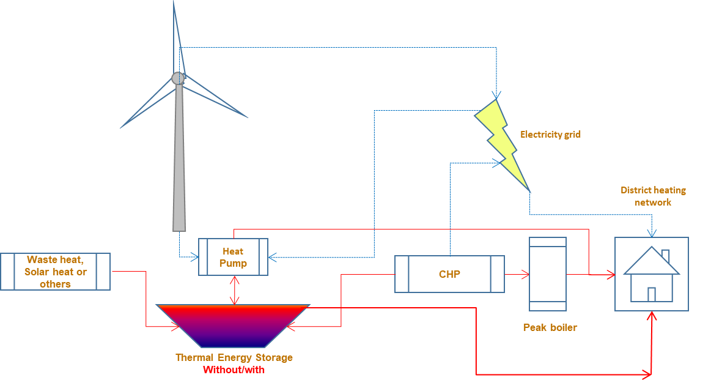

Schematic illustration of a district heating system with a large thermal energy storage

The cost of water pit heat storage consists of a basis cost of 12,300,000 DKK and a volumetric cost of 110 (DKK/m3 TES volume). The cost of tank heat storage consists of a basis cost 1,500,000 DKK and a volumetric cost of 750 (DKK/m3 TES volume).

It is assumed that there is perfect temperature stratification in the TES and that there are only two temperatures in the heat storage: Hot water temperature 80°C and cold water temperature 40°C. Detailed information on insulation of the heat storage can be found in Appendix C. The lifetime of the system/ components is 20 years. An interest rate of 1% for capital investment of the heat storage must be considered. It is assumed that the waste heat from industry is only available in the first two weeks of the year.

Please answer the following questions:

1. Consider a district heating plant without thermal energy storage, please determine the lowest annual heat production cost of the plant in DKK/MWh and explain how the plant can achieve it.
2. Now the plant plans to install a thermal energy storage, please determine the optimal volume of TES and the lowest heat production cost. Please advise the plant whether it is economically attractive to have a TES. Heat loss from the heat storage must be considered.
3. Determine dimensions of the water pit heat storage, for example, height, edge sizes.
4. Determine annual heat loss, heat recovery rate and utilization frequency of the PTES
5. Plot heat demand and heat production from various sources over the year.
6. Bonus exercise: parametric investigation and optimization considering at least one of the following factors, for example, fluctuation of natural gas price, electricity market price, waste heat percentage/price, annual heat demand, interest rate, electricity energy storage instead of thermal energy storage, energy flow, etc.

Appendix A the annual heat demand of the district heating system

|  |  |
| --- | --- |
| Student number | Annual heat demand, Q (MWh) |
| xxxxx1 | 16000 |
| xxxxx2 | 24000 |
| xxxxx3 | 32000 |
| xxxxx4 | 40000 |
| xxxxx5 | 48000 |
| xxxxx6 | 56000 |
| xxxxx7 | 64000 |
| xxxxx8 | 72000 |
| xxxxx9 | 80000 |
| xxxxx0 | 88000 |

Appendix B Degree hours

Degree-day and degree-hour values are commonly used for energy analyses of buildings.

Degree-hour values are calculated simply by summing up the differences between the hourly ambient air temperatures (Ta) and a standard reference temperature (base temperature,Tset). Cooling will not be considered in the assignment.

(1) Sum of degree hour over a year = $\sum_{1}^{8760}{(max(Tset-Ta,0))}$

A Tset of 18ᵒC could be used. Max(Tset-Ta,0) means using positive values only. All negative values will be set to zero.

Hourly ambient air temperatures Ta over a year can be found from DTU Learn.

(2) Distribution of hourly space heating demand

Hourly space heating demand, *i* th hour = degree hour, *i*th hour/Sum of degree hour*Annual space heating demand

A detailed explanation of degree days can be found in the following link: <https://www.degreedays.net/introduction>.

Appendix C Heat loss from the water pit heat storage (PTES)

Water depth of the PTES is 16 m. The slope of side of the PTES is 26.6°. The sky temperature is 15 K lower than the temperature of ambient air. The initial soil temperature (outside of the thermal influenced layer) is 10ᵒC. At a steady state condition the thermally influenced layer of soil around the PTES is 30 m thick. Thermal conductivity of soil around the PTES is constantly 0.7 W/m/K. The top cover has a PE insulation layer of 0.25 m. The thermal conductivity of PE is 0.045 W/m/K. An average wind speed over the PTES of 1 m/s can be assumed. Emissivity of the cover is 0.3.

For calculation of heat loss coefficient of the PTES, an average ambient air temperature can be used.

For the top cover, heat loss must be considered when there is hot water in the heat storage. If the heat storage is not full, the heat loss from the side/bottom can be downscaled by a weighting factor (stored heat/storage capacity).

Appendix D Annual payment for different interest rates

The investment in energy storage is financed by a 20 year loan with an annual interest rate. The annual payment for a 20 year loan is given in the following table for different interest rates.

|  |  |
| --- | --- |
| Annual interest rate | Annual payment/Amount of loan, % |
| 1.0% | -5.5415% |
| 1.5% | -5.8246% |
| 2.0% | -6.1157% |
| 2.5% | -6.4147% |
| 3.0% | -6.7216% |
| 3.5% | -7.0361% |
| 4.0% | -7.3582% |
| 4.5% | -7.6876% |
| 5.0% | -8.0243% |